F167030 – RX - Release Payment Holds
F167030 – RX Release Payment Holds
This document is the complete, production-ready architecture for enabling member self-service release of PBM mail-order “Payment Hold” in the Aetna portal using only PBM Experience API (REST) calls. It includes: scope & actors, end-to-end behavior, API contracts, PUML flows (sequence + optional activity), data models, error handling, NFRs, acceptance tests, and an ops runbook.
1) Scope & Goals (PBM-Only, REST-Only)
- Goal: Allow a member to clear a PBM mail-order RX payment hold when eligible.
- How:
- Detect eligibility via Experience API (REST) — shows “Change Payment Method” CTA when reason=54.
- Submit payment + consent via Experience API (REST).
- Resolve the payment hold via Experience API (REST).
- Refresh the order, purge cache, and audit.
Constraint: No new PBM endpoints. Use only existing Experience API routes.
2) Actors & Components
- Member (Portal Web/Mobile) — the end user.
- Aetna Portal — UI; calls Experience API; manages cache & audit locally.
- PBM Experience API (REST) — CVS Caremark APIs.
- Aetna Transient Cache — short-TTL RX/order cache (to be purged after action).
- Aetna Audit Store — append-only log of member actions and results.
3) End-to-End Behavior (Narrative)
Step 1 — Detect eligibility (read)
- Member opens RX details.
- Portal calls GET /experience/high-cost-hold?rxId={rxId}&memberId={memberId}.
- If response indicates status="ELIGIBLE", selfServeOption="PAYMENT_HOLD", and filters.fillStatusReasonCode=54, the UI renders “Change Payment Method” CTA with short guidance.
Response excerpt
{
"status": "ELIGIBLE",
"selfServeOption": "PAYMENT_HOLD",
"filters": {
"fillStatusReasonCode": 54
},
"displayValue": "Change Payment Method"
}
Step 2 — Submit payment & consent (action)
- Member confirms/enters a payment instrument and provides consent (Y/N).
- Portal calls:
POST /experience/payment-consent
Headers: Idempotency-Key: <uuid>, X-Trace-Id: <traceId>
Body:
{
"orderId": "ORD-10001",
"rx": [
{
"rxNumber": "1234567",
"consentResponse": "Y"
}
],
"paymentInstrument": {
"token": "pm_..."
},
"memberId": "M-12345",
"traceId": "<traceId>"
}
API returns { "status": "accepted", "consentReference": "CONS-9f2c3" }.
Step 3 — Resolve the payment hold (authoritative action)
Portal calls:
POST /experience/orders/{orderId}/resolve-payment-hold
Headers: Idempotency-Key: <uuid>, X-Trace-Id: <traceId>
Body:
{
"rx": [
{
"rxNumber": "1234567"
}
],
"memberId": "M-12345",
"consentReference": "CONS-9f2c3",
"traceId": "<traceId>"
}
API responds with { "result": "released", "auditId": "AUD-20251010-001" }.
If your Experience API models submit-consent and release as a single operation, collapse Steps 2 & 3 into:
POST /experience/orders/{orderId}/payment-hold:resolve
Headers: Idempotency-Key: <uuid>, X-Trace-Id: <traceId>
Body: { orderId, rx[], paymentInstrument, consentResponse, memberId, traceId }
Step 4 — Hygiene & confirmation
- Portal purges the transient RX/order cache.
- Portal writes an audit entry with actor, IDs, traceId, and the provider-returned auditId.
- Portal calls GET /experience/orders/{orderId} and confirms the hold is gone.
- UI shows success: “Payment hold released. Your order will continue processing.”
- On any error, UI shows provider message and enables retry.
4) Flows
4.1 Sequence (REST-only via Experience API)
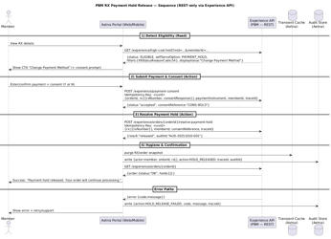
4.2 Activity
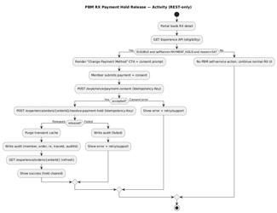
5) API Contracts (Experience API — REST)
Replace placeholders with the exact provider paths/fields from PBM team exposes.
5.1 Eligibility (read)
- GET /experience/high-cost-hold?rxId={rxId}&memberId={memberId}
- 200:
{
"status": "ELIGIBLE",
"selfServeOption": "PAYMENT_HOLD",
"filters": {
"fillStatusReasonCode": 54
},
"displayValue": "Change Payment Method"
}
5.2 Submit payment + consent (action)
- POST /experience/payment-consent
- Headers: Idempotency-Key, X-Trace-Id
- Body:
{
"orderId": "ORD-10001",
"rx": [
{
"rxNumber": "1234567",
"consentResponse": "Y"
}
],
"paymentInstrument": {
"token": "pm_..."
},
"memberId": "M-12345",
"traceId": "..."
}
202/200:
{
"status": "accepted",
"consentReference": "CONS-9f2c3"
}
5.3 Resolve payment hold (action)
- POST /experience/orders/{orderId}/resolve-payment-hold
- Headers: Idempotency-Key, X-Trace-Id
- Body:
{
"rx": [
{
"rxNumber": "1234567"
}
],
"memberId": "M-12345",
"consentReference": "CONS-9f2c3",
"traceId": "..."
}
200:
{
"result": "released",
"auditId": "AUD-20251010-001"
}
5.4 Refresh order (read)
- GET /experience/orders/{orderId}
- 200 (excerpt):
{
"order": {
"status": "OK",
"holds": []
}
}
6) Data Shapes (Portal-side)
PaymentConsentSubmission
{
"orderId": "ORD-10001",
"rx": [
{
"rxNumber": "1234567",
"consentResponse": "Y"
}
],
"paymentInstrument": {
"token": "pm_..."
},
"memberId": "M-12345",
"traceId": "TRACE-..."
}
HoldResolutionRequest
{
"rx": [
{
"rxNumber": "1234567"
}
],
"memberId": "M-12345",
"consentReference": "CONS-9f2c3",
"traceId": "TRACE-..."
}
AuditEvent (Aetna-owned)
{
"auditId": "AUD-20251010-001",
"actor": {
"type": "MEMBER",
"id": "M-12345"
},
"domain": "PBM",
"orderId": "ORD-10001",
"rx": [
"1234567"
],
"action": "HOLD_RELEASED",
"traceId": "TRACE-...",
"timestamp": "2025-10-10T14:31:22Z"
}
7) Error Handling & Edge Cases
- Eligibility false/changed: Don’t show CTA; re-check on page refresh or after order changes.
- Consent rejected: Show provider message; allow retry. Log an audit entry with status.
- Resolve failed: Persist failure audit; present readable message & retry.
- Idempotency: Replays with same Idempotency-Key must not double-apply actions.
- Multiple RX: Support array of rxNumber; only release the RX the member authorized.
8) Non-Functional Requirements
- Transport: REST only (Experience API).
- Availability: Portal remains usable (read-only) when actions are unavailable.
- Latency targets: p95 GET ≤ 300 ms; p95 POST ≤ 600 ms.
- Security: payment instruments are tokenized; minimum identifiers in payloads.
- Observability: X-Trace-Id propagated; dashboards for success/error rates, retry counts, and time-to-release.
- Compliance: Append-only audit for every attempt (success or failure).
- Rate limiting: Client-side throttles to avoid accidental hammering on repeated retries.
9) Acceptance Criteria
- Eligibility rendering: RX with reason 54 consistently returns ELIGIBLE/PAYMENT_HOLD; CTA visible.
- Consent submission: POST /experience/payment-consent accepts tokenized payment; returns a consentReference.
- Release: POST /experience/orders/{orderId}/resolve-payment-hold returns {result:"released", auditId}; subsequent refresh shows no hold.
- Idempotency: Duplicate POSTs with the same key return the original result without duplicate side effects.
- Audit & Telemetry: Every attempt (success/failure) is recorded with actor, IDs, traceId, and provider status.
- UX: Errors show provider messages; retry is available; success toast shown and detail reflects updated state.
10) Ops Runbook
- Provider outage (Experience API): surface friendly error; enable retry; log failure audit; monitor backlog & success recovery after restoration.
- Portal instability: fall back to read-only; suppress actions where possible; keep eligibility checks but avoid POSTs until stable.
- Hotfix knobs: feature flag to hide the CTA globally; adjustable retry backoff; configurable idempotency key TTL.
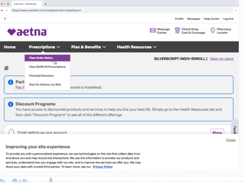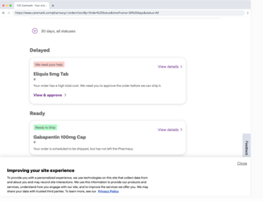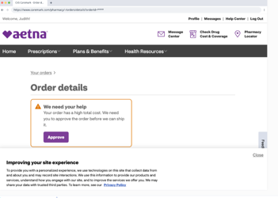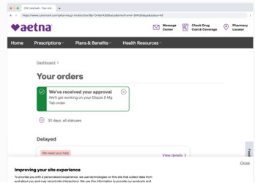
CVS
